CROQUET

CROQUET ORIGINATED IN FRANCE DURING THE 13th CENTURY AND WAS A POPULAR GAME WITH ROYAL FAMILIES IN FRANCE DURING THE 17th CENTURY WHEN IT CAME ACROSS THE CHANNEL TO ENGLAND AND

BECAME THE GAME OF KING’S AND QUEENS. CROQUET IS NOW PLAYED IN MOST OF THE COUNTRIES OF THE WORLD.

FIELD LAYOUT: (SEE DIAGRAM) THE LAYOUT IS DETERMINED BY AVAILABLE SPACE BUT SHOULD NOT EXCEED 40ft/12mtrs X 75ft/23mtrs. THE PLAYING FIELD CONSISTS OF NINE WICKETS AND FOUR WOODEN STAKES. THE BOUNDARY LINE IS USUALLY approx. 7ft/2.2mtrs FROM THE END STAKES AND 5ft/1.5mtrs FROM THE SIDE WICKETS.
PLACEMENT OF WICKETS: THE FIRST WICKET IS PLACED ONE MALLET’S HANDLE LENGTH FROM THE STARTING STAKES/POSTS AND THE SAME DISTANCE IS USED IN MEASURING PLACEMENT OF THE SECOND WICKET. THE SAME APPLIES TO WICKETS SIX AND SEVEN AT THE TURNING STAKES. CONSULT DIAGRAM FOR PLACEMENT OF REMAINING WICKETS.
ORDER OF PLAY: THIS IS DETERMINED BY THE COLOURED STRIPES ON THE WOODEN END STAKES. TOP COLOUR PLAYS FIRST AND SO ON.
OBJECT: TO MOVE YOUR BALL BY STROKING OR HITTING IT THROUGH THE WICKETS IN THE SEQUENCE OR ORDER SHOWN IN THE DIAGRAM. THE FIRST PLAYER OR TEAM TO COMPLETE THE CIRCUIT WINS THE GAME.

RULES

PLAY BEGINS BY PLACING THE BALL A MALLET HEADS’ LENGTH FROM WICKET

NUMBER ONE OR BETWEEN THE STARTING STAKES/POSTS WHICH CAN BE PLACED AT THIS REQUIRED DISTANCE. THEN HIT OR STROKE THE BALL THROUGH THE WICKETS.
- FOR EACH WICKET YOUR BALL PASSES THROUGH YOU RECEIVE AN ADDITIONAL STROKE.
- IF A PLAYER GAINS TWO STROKES BUT PASSES THROUGH ANOTHER WICKET IN ONE STROKE THE SECOND STROKE IS NOT CARRIED OVER BUT YOU ARE STILL ENTITLES TO ONE ADDITONAL STROKE BY VIRTUE OF PASSING THROUGH THE WICKET.
- ANY MOVEMENT OF THE BALL CONSTITUTES A STROKE EXCEPT IF THE BALL IS COMPLETELY MISSED.
- A SINGLE STROKE IS WON BY HITTING ONE OF THE TURNING STAKES BEHIND WICKET NUMBER SEVEN. THE BALL MUST BE PLAYED FROM WHERE IT STOPPED. IT MUST PASS THROUGH THE TURNING STAKES (but may have already done so when striking one of these stakes after passing through wicket seven).
- WHEN A PLAYER HAS HIT ANY OTHER BALL WITH HIS OWN, HE MAY TAKE ONE MORE SHOT FROM WHERE HIS BALL LIES OR HE MAY PLACE HIS BALL A MALLET HEADS’ DISTANCE IN ANY DIRECTION FROM THE BALL HE HAS HIT AND TAKE TWO SHOTS; OR HE MAY PLACE HIS BALL AGAINST THE OTHER, STEP ON HIS BALL WITH ONE FOOT AND STRIKE HIS BALL FIRMLY TO DRIVE THE OTHER AWAY, AND THEN TAKE ONE ADDITIONAL SHOT; OR HE MAY PLACE HIS BALL AGAINST THE OTHER AND DRIVE BOTH BALLS IN THE SAME DIRECTION AT ANY ANGLE. CONTINUED OVER ……
- ANY BALL DRIVEN THROUGH A WICKET COUNTS EXCEPT IF YOUR BALL HITS ANOTHER AND THEN PASSES THROUGH A WICKET. IN THIS CASE, YOU MUST PLAY YOUR BALL FROM THE HIT BALL AS IN RULE ‘6’. IF BOTH BALLS PASS THROUGH THE WICKET THEN YOU RECEIVE AN ADDITIONAL STROKE AND YOUR BALL PLAYS FROM THE NEW POSITION.
- WHEN A PLAYERS BALL HITS TWO OTHER BALLS HE MUST PLAY OFF THE FIRST BALL HIT
- A BALL HAS NOT PASSED THROUGH A WICKET IF THE STRAIGHT HANDLE OF A MALLET TOUCHES THE BALL WHEN LAID ACROSS THE WICKET ON THE SIDE FROM WHICH THE BALL CAME.
- IF WHILE STROKING THE BALL YOUR MALLET TOUCHES THE WICKET YOU ARE ATTEMPTING TO MAKE, YOU FORFEIT THE TURN AND REPLACE THE BALL TO ITS ORIGINAL POSITION.
- BALLS HIT OUT OF BOUNDS ARE REPLACED ON THE BOUNDARY LINE AT THE POINT WHERE THEY WERE KNOCKED OUT
- WHEN A PLAYER HITS OUT OF TURN, ALL BALLS ARE REPLACED. THERE IS NO PENALTY.
- IF A PLAYER HITS THE WRONG BALL, THE BALL IS REPLACED AND THE PLAYER LOSES HIS TURN.
- A ROVER IS THAT PLAYER WHO HAS COMPLETED THE CIRCUIT EXCEPT FOR HITTING ONE OF THE STARTING STAKE AND REMAINS IN THE GAME TO AID HIS PARTNER. A ROVER MAY NOT STRIKE THE SAME BALL TWICE IN SUCCESSION.
- IN A PARTNER’S GAME, PLAYERS ALTERNATE WITH OPPONENTS. A ROVER MAY NOT BE HIT BY AN OPPONENT INTO THE STARTING STAKES FOR THE PURPOSE OF PUTTING HIM OUT OF THE GAME.

THE COURT ……..

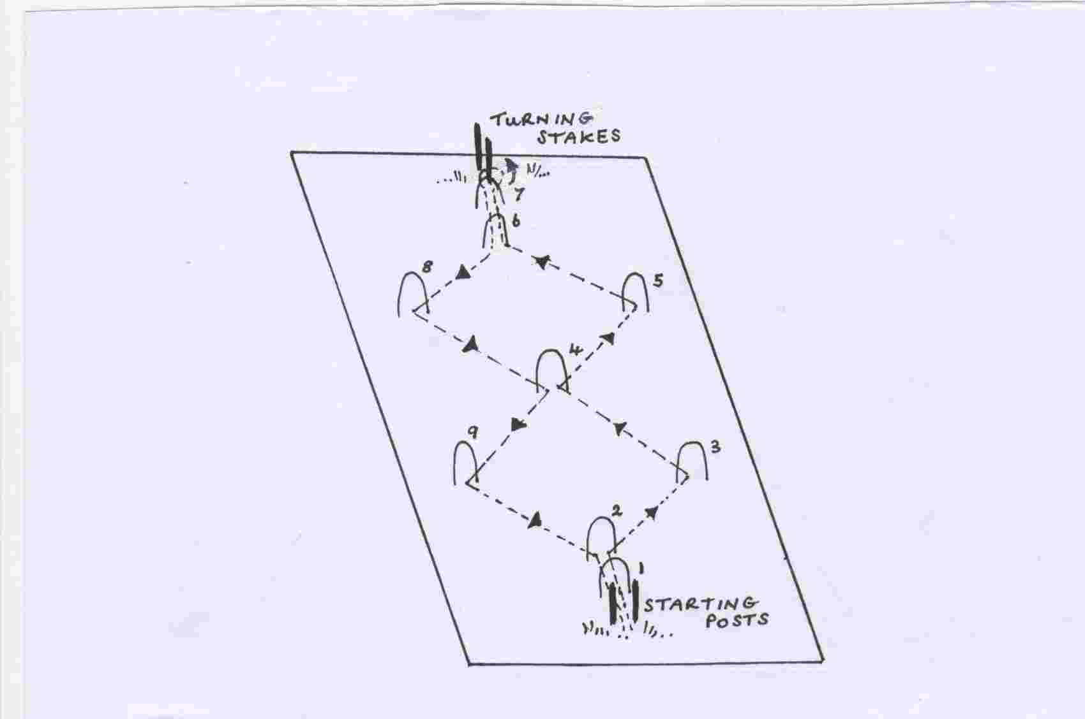
WARNING THIS IS NOT A TOY.
CHILDREN SHOULD ONLY USE WHEN SUPERVISED BY AN ADULT

www.traditionalgardengames.co.uk

